SIX LARGE CANVASES BY CLEVE GRAY NEWLY ACCESSIONED TO THE COLLECTION OF THE JEWISH MUSEUM IN PRAGUE

FOR IMMEDIATE RELEASE

(PRAGUE, March 29, 2023) Six large format canvases by American artist Cleve Gray (September 22, 1918, New York, NY— December 8, 2004, Hartford, CT) represent one of the most significant donations that the Jewish Museum in Prague has received during the entire period of its postwar existence. At the same time, they are a rare testimony reflecting upon an encounter of a leading figure of Abstract expressionism and Color field painting with the genius loci of Jewish Prague from nearly four decades ago.

The paintings are part of the extensive series entitled In Prague, which Gray created under the immediate impression of a visit to the Czech capital. During his journey behind the Iron Curtain undertaken in 1984, the artist was deeply affected particularly by the Old Jewish Cemetery. He described this powerful experience fourteen years later in an interview with American art historian Nicholas Fox Weber:

“I was absolutely staggered. The Jewish Cemetery did something powerful to me. It freed me of my deepest fears, like a self-psychoanalysis. It represented terrors I had fought against for a long time: the suffering of the Jews, the sense that I, too, might be dragged out in the night, the terrible submerged fear that I would re-experience what had happened to the Jews over centuries. […] Seeing that cemetery was a frightening and moving experience. The graves are piled up, layers upon layers of tombstones, accumulating there because the Jews were not allowed to expand even in death outside the ghetto. Those stones spoke of the desire to dignify the human spirit in death. They became for me a metaphor for indomitability of dream and prayer. In life, at a time when hope seems impossible.”

The Museum received the donation from the Cleve Gray Foundation represented by the artist's sons, Luke and Thaddeus Gray, who commented on their decision: “On behalf of the Cleve Gray Foundation, we would like to express the joy we feel in donating these paintings to the Jewish Museum in Prague. We have no doubt that this is their real home, and that the donation merely fulfills the destiny that was intended for them from the start.”

For more information please contact:
Michaela Sidenberg, Curator in Chief, Jewish Museum in Prague
michaela.sidenberg@jewishmuseum.cz / +420 606 748 236

For high-quality images please contact:
Gabriela Zadražilová, Head of Public Relations
gabriela.zadrazilova@jewishmuseum.cz / +420 605 246 233

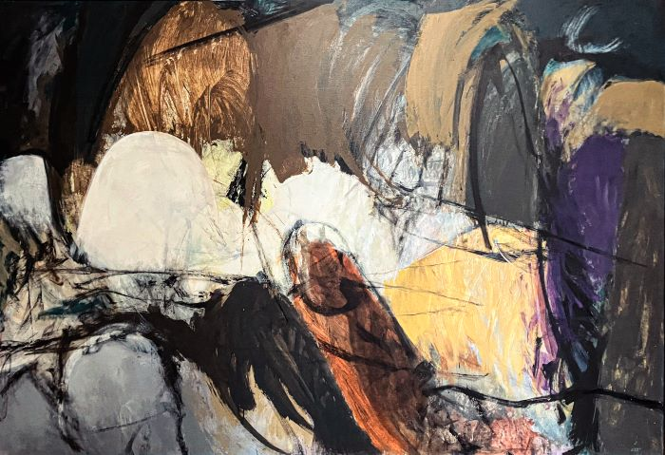
Cleve Gray: In Prague no. 19, acrylic on canvas, 150 x 216 cm, 1984. Photo: Jewish Museum in Prague
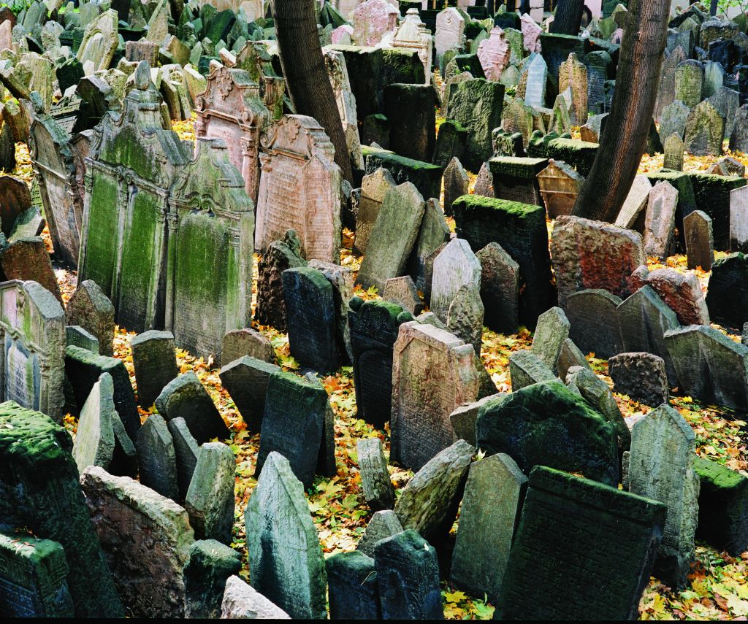
Old Jewish Cemetary in Prague. Photo: Jewish Museum in Prague

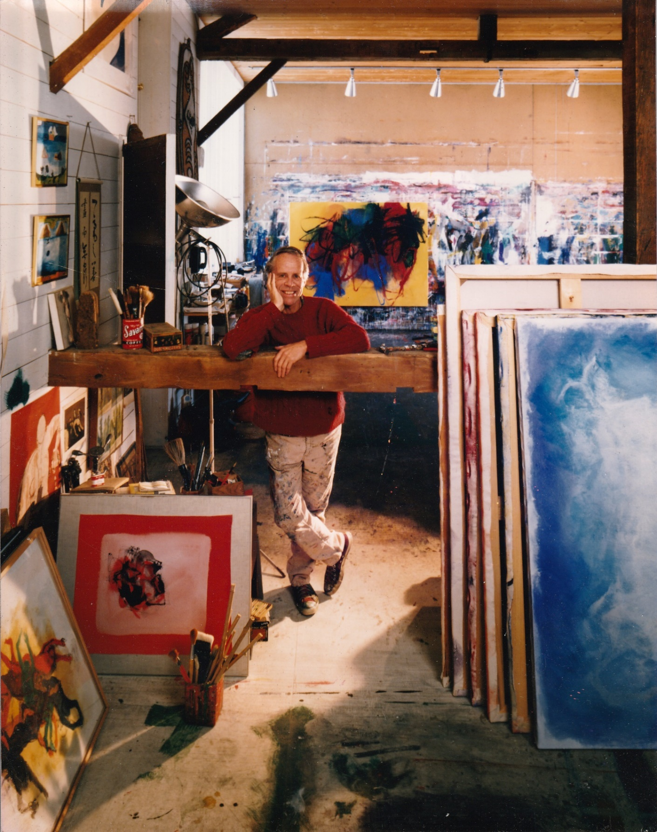
Cleve Gray in his studio. Photo: Gray Art Partners, LLC

