**GERTRUD KAUDERS IS NOW PART OF THE PERMANENT COLLECTION AT THE JEWISH MUSEUM IN PRAGUE**

FOR IMMEDIATE RELEASE

(PRAGUE, July 26, 2023)

**After several years of negotiations, the Jewish Museum in Prague is about to receive a substantial portion of a unique trove of art that was discovered in the spring of 2018. Specifically, several hundreds of paintings and drawings by the artist Gertrud Kauders have been donated to the museum. Kauders lived in Prague at the same time as Franz Kafka but, unlike her famous contemporary, remained completely forgotten for nearly eighty years.**

What makes Gertrud Kauders’ story similar to Kafka’s is the fact that her artistic legacy was also rescued by a friend. In Kauders’ case, it was the painter Natalie Jahůdková, who she met while studying landscape painting at Prague’s Academy of Fine Arts in the mid–1920s. Born in Moscow in 1895, Jahůdková (née Natalia Ivanovna Schtutzer) lived in a house in the southern Prague suburb of Zbraslav, initially with her husband (Josef Jahůdka, a former lieutenant in the Czechoslovak Legion) and later alone after her husband’s death in 1938. For nearly eighty years, Kauders’ unique artworks were concealed in this unassuming suburb residence, a secret repository known only to Jahůdková’s closest relatives.

Gertrud Kauders(April 26, 1883, Prague—after May 17, 1942, Majdanek) was the daughter of lawyer Sigmund Kauders (1848–1919) and Emilie (Emmy), née Benda (1857–1923). Both of her parents came from well-established Prague Jewish families. Her mother was the sister of Gustav von Benda (1846–1932), a prominent art collector in Vienna.

Gertrud, or Gerti as nicknamed by her family and friends, remained single throughout her life. Her father ensured her financial independence after she came of age, which meant that she could pursue her passion for art. She first studied with Max Feldbauer (1869–1948), a painter associated with the Munich Secession, who taught at the Ladies’ Academy (*Damenakademie*) of the Munich Association of Women Artists between 1901 and 1915. Modeled on the private art academies of Paris, this school provided formal art education to women, who – with some exceptions – were otherwise denied, in most European countries, the opportunity to enroll in traditional art schools, which remained the preserve of men until the end of the First World War. Gertrud continued her art studies in Paris and later in Prague at the Ukrainian Academy and, in 1926, in the landscape painting class led by the artist Otakar Nejedlý (1883–1957).

Apart from short-term artist residencies and study travels, Gertrud spent all of her life in Prague, where she was active in German-speaking artistic circles. In addition to her own art work, she also focused on pedagogical activities — teaching drawing to children in classes organized by the German educational and cultural association Urania. On May 12, 1942, she was deported

from Prague to the Theresienstadt ghetto and from there, almost immediately, sent to the ghetto of Lublin which, however, she never reached. On that gruesome journey, she did not pass the selection and was sent to the Majdanek extermination camp, where she was murdered. Before being deported from Prague, Gertrud managed to transfer all of her artworks from her studio to a friend’s house in Zbraslav. More than a hundred canvases, untacked from stretchers, and nearly 600 drawings were hidden throughout the structure of the house. They remained concealed there until the spring of 2018, when some of the artworks were discovered by demolition workers who had started dismantling the house. Hidden away for so long, Kauders’ paintings and drawings were virtually unknown until their discovery.

Descendants of Gertrud’s only nephew, Cornelius Kauders, who live in New Zealand and Australia, learned of the discovery in 2019. After long negotiations, an agreement was reached in May 2022 for the return of the artworks. About a year later, a final decision was attained on how to do justice to Gertrud’ artistic legacy. It goes without saying that the collection is of greatest value in its entirety as it represents an authentic imprint of the artist’s studio. The heirs, however, ultimately concluded that it would be best to divide the large set into several smaller units, so that it can be represented in several major collections across three continents. This means that we will be able to see Gertrud Kauders’ art in New York, Washington, D.C., and Wellington, New Zealand. Nearly 380 of the works, the majority of which are drawings, have been donated to the Jewish Museum in Prague. The museum’s chief curator, Misha Sidenberg, has been involved in the rescue and documentation of this unique find from the very beginning.

The initial examination of paintings. Photo © Dana Cabanová, JMP

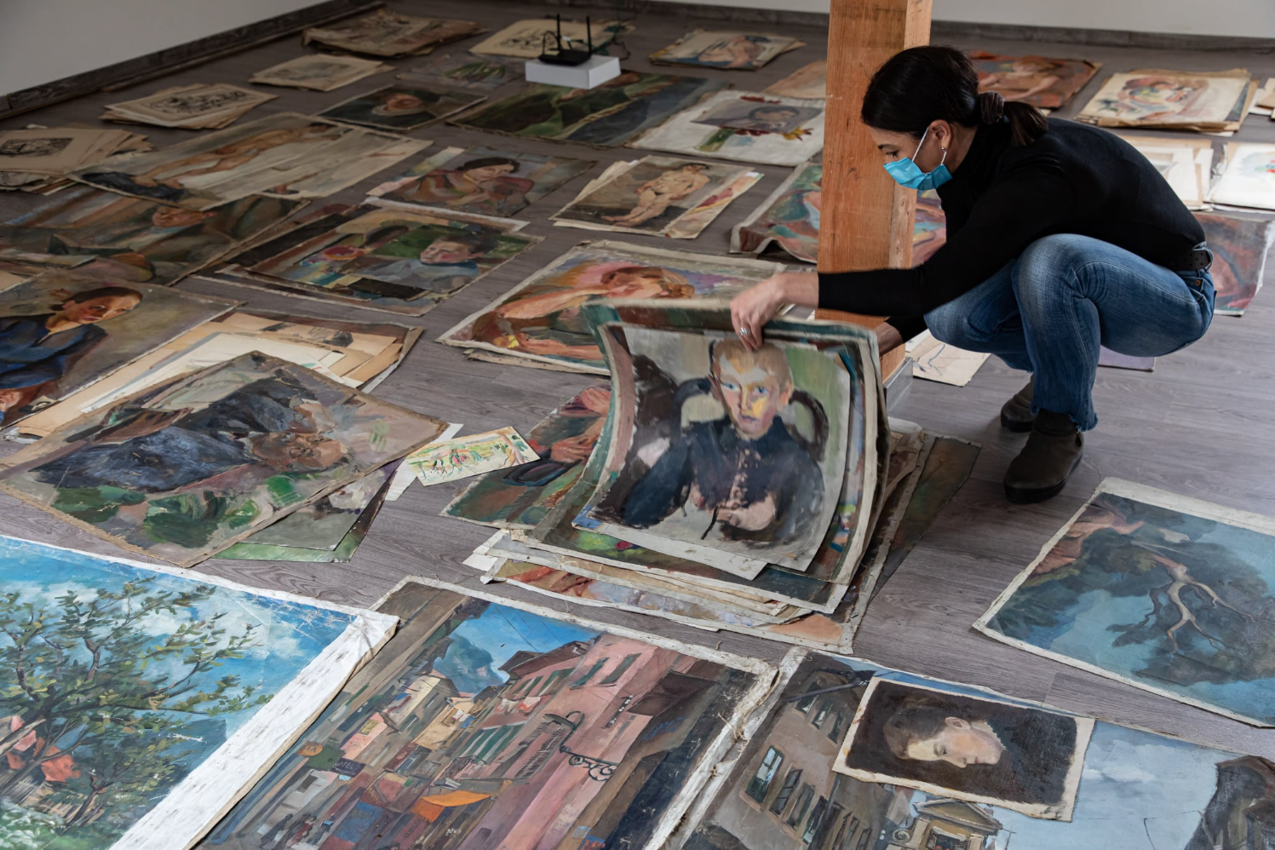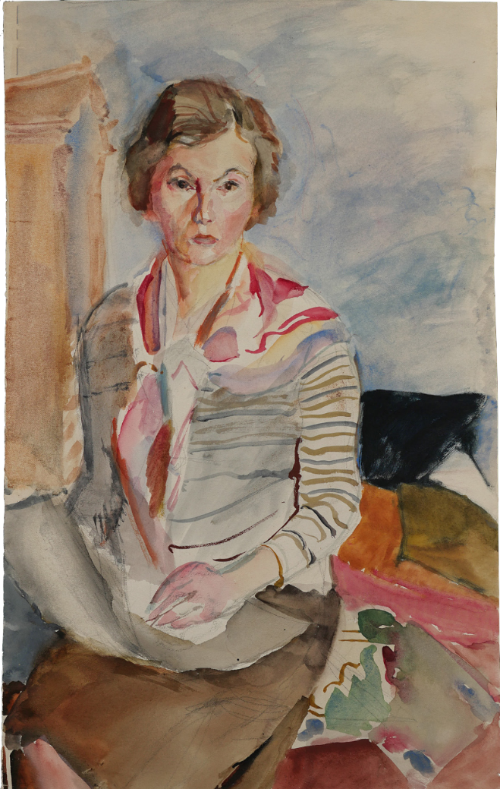

Gertrud Kauders: Selfportrait, around 1930

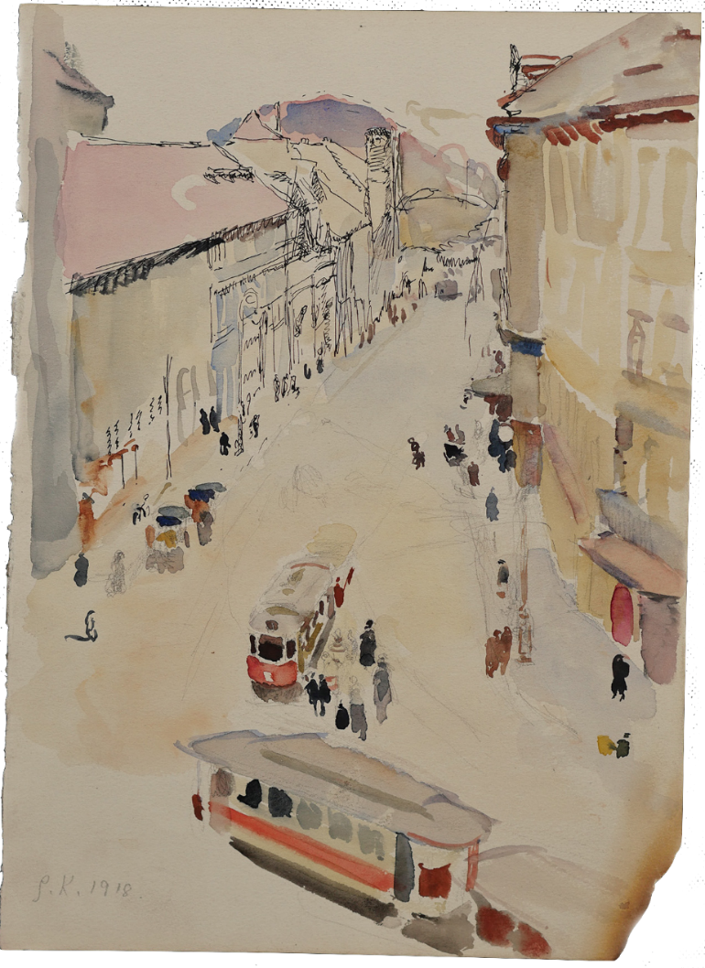

Gertrud Kauders: Hybernská St., Prague 1918

**For more information and hi-res images please contact:**

Misha Sidenberg, Chief Curator, Jewish Museum in Prague.

[michaela.sidenberg@jewishmuseum.cz](mailto:michaela.sidenberg@jewishmuseum.cz) / tel. +420 606 748 236

Gabriela Zadražilová, Head of Public Relations, Jewish Museum in Prague

[gabriela.zadrazilova@jewishmuseum.cz](mailto:gabriela.zadrazilova@jewishmuseum.cz) / tel. +420 605 246 233