THE RETURN OF FOUR SYNAGOGUE TEXTILES TO THE COLLECTIONS OF THE JEWISH MUSEUM IN PRAGUE

FOR IMMEDIATE RELEASE

(PRAGUE, October 17, 2022) At the beginning of this June, experts from the Jewish Museum in Prague – as part of their systematic monitoring of the global art market – discovered that four items on sale at the J. Greenstein & Co. auction house in New York had passed through the museum’s collections during the Nazi occupation and had disappeared in the post-war period. The items in question are textiles that, along with tens of thousands of other primarily ritual objects, were transferred to Prague between 1942 and 1944 from rural Jewish communities that had been forcibly disbanded by the Nazis and whose existence was supposed to remain forever forgotten.

The restitution of the four textiles identified in New York is one of those cases that can be described as an example of good practice to follow, thanks to the helpfulness and cooperation of the art dealer. This is not the first time that the museum has encountered such willingness from dealers and/or their consignors who have agreed to a just and fair solution of a claim by returning the items in question to their rightful owner, which for all these cases is the Federation of Jewish Communities in the Czech Republic (FJC). In the past, for example, a Torah ark curtain from Mladá Vožice and a Torah mantle from Holešov have been voluntarily returned to the FJC by their holders.

The items that are now being returned to the museum – namely, a Torah ark curtain, a Torah mantle, and two Torah reading table covers – do not form a coherent set, as they are not linked by commissioner, maker, style or by the date or place of origin. Each piece was used by a different Jewish community, not even one of which has been in existence for decades. Nevertheless, each of the four textiles in its own unique way is a precious historical record and a tangible reminder of the existence not only of the communities themselves, but – in two cases – also of their individual members whose names are recorded in the embroidered dedications. Whereas the two Torah reading table covers were donated to the respective congregations as collective gifts by women’s associations – the first, dating from 1884, was given to the synagogue in Krásno - Valašské Meziříčí, the second, dating from the early 20th century, was a gift to one of the synagogues in Boskovice, the dedications on the other two items refer to individual donors and to the important events for which their donations were made.

From the inscription on the Torah mantle from the town of Kostel (present-day Podivín) we know that it was donated to the local synagogue in 1899 by a certain Mendel, son of Salomon Spitz, and his wife Michla, daughter of Michael Schick, on the occasion of his 80th birthday. The inscription on the Torah ark curtain, which is made of white repp (a horizontally ribbed fabric), mentions that it was commissioned by Abraham Langschur and his wife Pesla from Ronšperk/Ronsperg (now Poběžovice) on the occasion of the birth of their son Menachem on 12 Sivan in the year 640 according to the small count (i.e. 22 May 1880). The curtain is the rarest of all the items, as it comes from a place, which, from the autumn of 1938, was part of the southernmost territory of the Sudetengau. Due to the fact that the situation in the Sudetenland – which was annexed to the German Reich on 30 September 1938 following the signing of the Munich Agreement – was different from that of the Protectorate of Bohemia and Moravia, the collections of the Jewish Museum in Prague contain (apart from a few exceptions) almost no objects from this territory.

The return to the Czech Republic of these objects, which are an important part of the country’s cultural heritage, was made possible thanks to the assistance of the Czech Embassy in Washington, D.C. and the

Czech Government. The Czech Ambassador to the U.S., Miloslav Stašek, had this to say: “The physical liquidation of members of the Jewish communities in Bohemia and Moravia was preceded and accompanied by economic liquidation. Private and communal property was initially stolen by the Nazis, and what remained was often lost in the post-war period. The lives of the victims cannot be returned. However, we must strive to recover our cultural heritage so that future generations can enjoy and learn from it. I am very glad that the Czech Embassy in Washington has recently been successful in this endeavor, whether it was acquiring the estate of the film director Ivan Passer, repatriating a precious Renaissance shield to Konopiště Castle, or, in this case, returning valuable synagogue textiles to the collections of the Jewish Museum in Prague.”

The director of the Jewish Museum in Prague, Leo Pavlát, to whom the objects were handed over in person at the museum’s headquarters on October 17, 2022, added the following words: “The Judaica in the collections of our museum bear witness to the centuries-long diverse and multifaceted life of Jewish communities in Bohemia and Moravia, which was tragically interrupted by the Nazi occupation. It is both a privilege and a duty to care for this heritage that once belonged to the victims of the Shoah. This is why every additional seemingly lost object from the heritage of the Jewish past that we can restitute to the museum collection is extremely important to us.”

Wartime history — how the objects become part of the museum’s collection

Even before the deportation of all Jews from the rural areas of the so-called Protectorate of Bohemia and Moravia as part of the Nazi genocidal plan, the Prague Jewish community – specifically its department for rural affairs – managed to organize an unprecedented rescue mission. This involved an appeal to the representatives of other Jewish communities in the Protectorate to send to Prague valuable items of their movable heritage that were in danger of destruction or alienation. The appeal met with a positive response. The consignments of these items, each embodying the memory of individual communities that had been carefully preserved over the centuries, gradually became part of the collections of the Jewish Museum in Prague between 1942 and 1944. At the time, the museum operated under the name “Central Jewish Museum”, a special project overseen by the Nazi Central Office for the Regulation of the Jewish Question (Zentralamt für Regelung der Judenfrage). However, it was created on the initiative of specific individuals who were active within Prague’s Jewish community. A specialist team of Jewish curators – art historians and Hebraists – worked on the museum’s project in an attempt to take advantage of the situation by preserving the legacy of their own culture, which was being systematically destroyed by the Nazis.

Postwar history — how the objects were alienated and illegally exported

Of the 136 Jewish religious communities that had been in existence in Bohemia and Moravia before the war, 53 were revived in the first post-war years. In order to restore their religious life, an umbrella organization that brought these communities together (the Council of Jewish Religious Communities, which after 1989 was succeeded by the Federation of Jewish Communities in the Czech Republic) redistributed some select ceremonial objects from the museum’s collections to individual congregations. These items were provided on loan solely for liturgical purposes. They were not donated and there was no transfer of ownership rights of any sort. When the original purpose of the loan could no longer be fulfilled (typically because most of the reestablished communities soon became defunct again due to political and demographic changes), the items

on loan were supposed to be returned to the museum’s collections. In the vast majority of cases, however,
this did not happen and the items were unlawfully alienated and often illegally exported from the territory of the former Czechoslovakia. Many Judaica objects of Bohemian and Moravian provenance were taken abroad in this way. Despite this fraudulent conversion, these objects never ceased to be the property of the Jewish communities from which they had originated – or, by extension, of the communities’ sole legal successor, the present-day Federation of Jewish Communities in the Czech Republic.

The current state — systematic monitoring of the art market, repatriation, and restitution

Long-missing ceremonial Judaica – an essential and integral part of the cultural heritage and memory of the Czech Republic’s Jewish community at large – have been turning up on the global art market in the last 25 years or so. This is why the Jewish Museum in Prague systematically monitors sales by both renowned and less known auction houses, as well as sales by brick-and-mortar antique shops. When the museum identifies an object that has verifiably passed through its collections, it presses a duly substantiated restitution claim on behalf of the Federation of Jewish Communities in the Czech Republic.

Abraham Langschur (22 June 1841 — 3 September 1923)

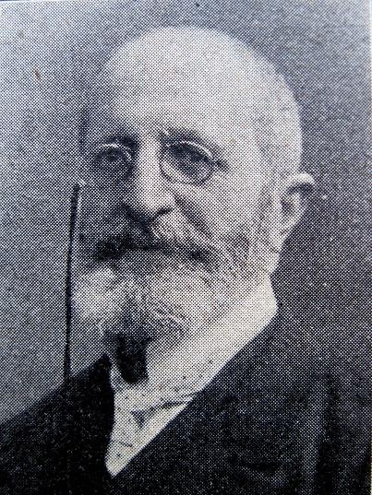
Abraham Langschur was born as one of twins in house no. 45 in Ronšperk/Ronsperg (now Poběžovice), western Bohemia. After attending the local Jewish and public school, he moved on to the Realschule in nearby Domažlice/Taus. He then undertook an apprenticeship at Michael Teller’s sugar factory in Prague and was later employed for many years as a clerk in Jakob Fürth’s factory in Sušice/Schüttenhofen. On 16 June 1869 he married Paulina (also known as Pesla or Philippine), neé Grüner(t) (2 April 1849 — 28 April 1928) from Tachov/Tachau. For more than 40 years, he headed both the Jewish religious community of Ronsperg and the local burial society. He was also a leaseholder of the local brewery, which was owned by Count Coudenhove-Kalergi. From 1905 he operated a shop in his own house (no. 8) on the town square. He was also a member of the town council. In addition, he was responsible for the documentation, extension, and repair of the Jewish cemetery, as well as for the reconstruction of the synagogue, for which he was able to raise substantial funds from wealthy compatriots in the United States. His marriage produced no fewer than twelve children, of which six daughters and three sons survived into adulthood. Menachem (Gustav, 22 May 1880 – 3 March 1939), who is mentioned in the the dedication on the Torah ark curtain, died just before the Nazi occupation. Hugo (25 June 1888 – 25 September 1914) succumbed to dysentery in a military hospital in Uzhhorod. Siegmund (8 June 1884 – after 28 July 1942) was deported with his wife to the Baranovichi ghetto (in present-day Belarus) and murdered in one of the extermination camps in the territory of the then General Government of Nazi occupied Poland. A similar fate befell Langschur’s other siblings who were still alive at the time. Sofie Glauber (23 December 1871 – after 19 October 1942), who was the last chairwoman of the Talmud Torah charity association in Tachov, perished in Treblinka. Terezie Grünhut (26 December 1877 – 10 October 1942) died of a stroke in the Terezin/Theresienstadt ghetto. Elisabeth (Betty) Steiner (January 25, 1891 - August 18, 1978) was the only one of Abraham and Pauline Langschur’s many children who survived the Shoah. After the war she lived in Gloucester, Massachusetts.

Bibliographical references:
Gold, Hugo: Die Juden und Judengemeinden Böhmens in Vergangenheit und Gegenwart, pp. 575-576; pp. 636

For additional information:
Michaela Sidenberg, Chief Curator, Jewish Museum in Prague, michaela.sidenberg@jewishmuseum.cz / +420.606.748.236

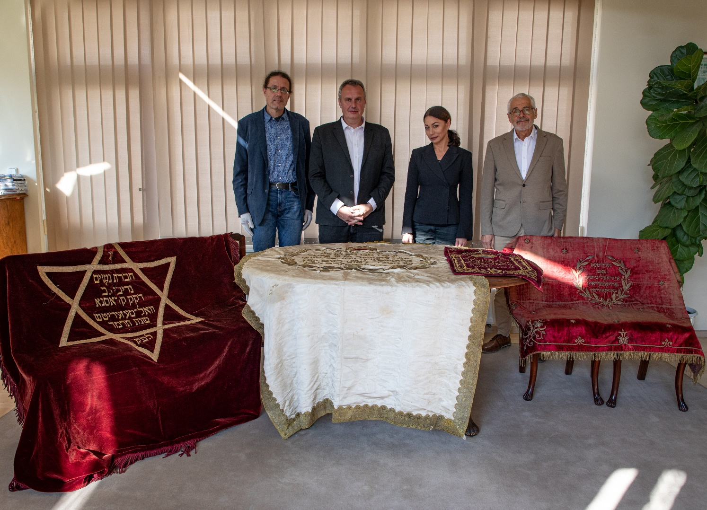
Handover of textiles in ŽMP
from left Milan Jančo / curator of textiles at the JMP, Tomáš Pojar/ Advisor to the Prime Minister for Foreign and Security Policy, Michaela Sidenberg / chief curator of the JMP, Leo Pavlát/director of the JMP

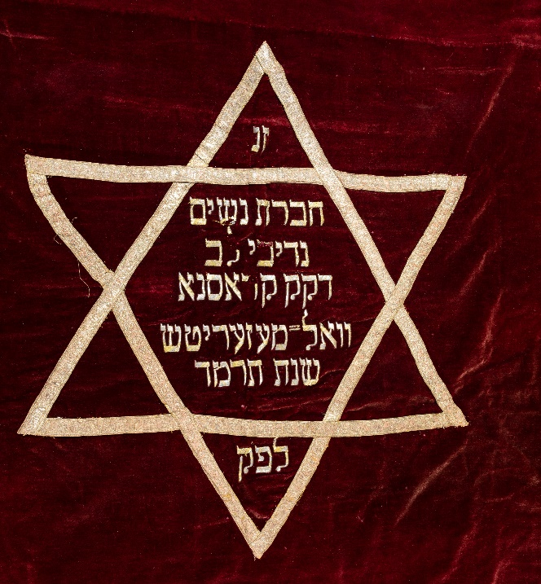
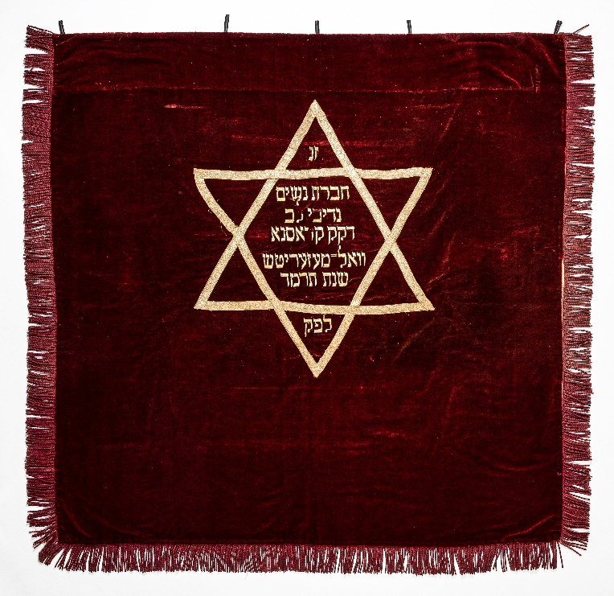
Torah reading table cover – Valašské Meziříčí (detail)
Torah reading table cover – Valašské Meziříčí

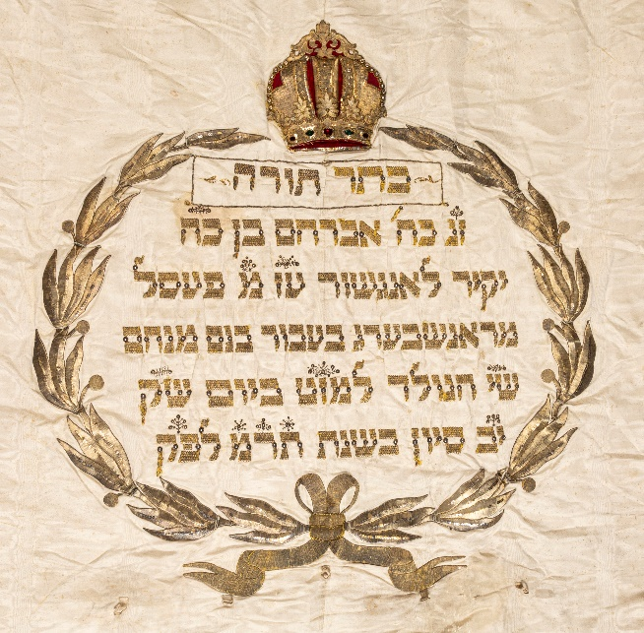
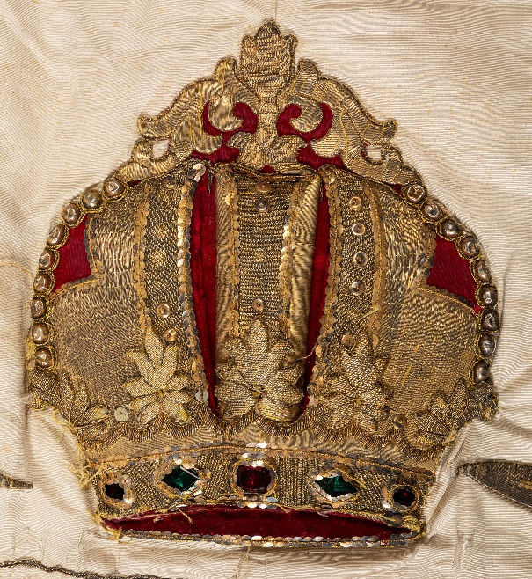
Torah ark curtain – Poběžovice (detail)
Torah ark curtain – Poběžovice
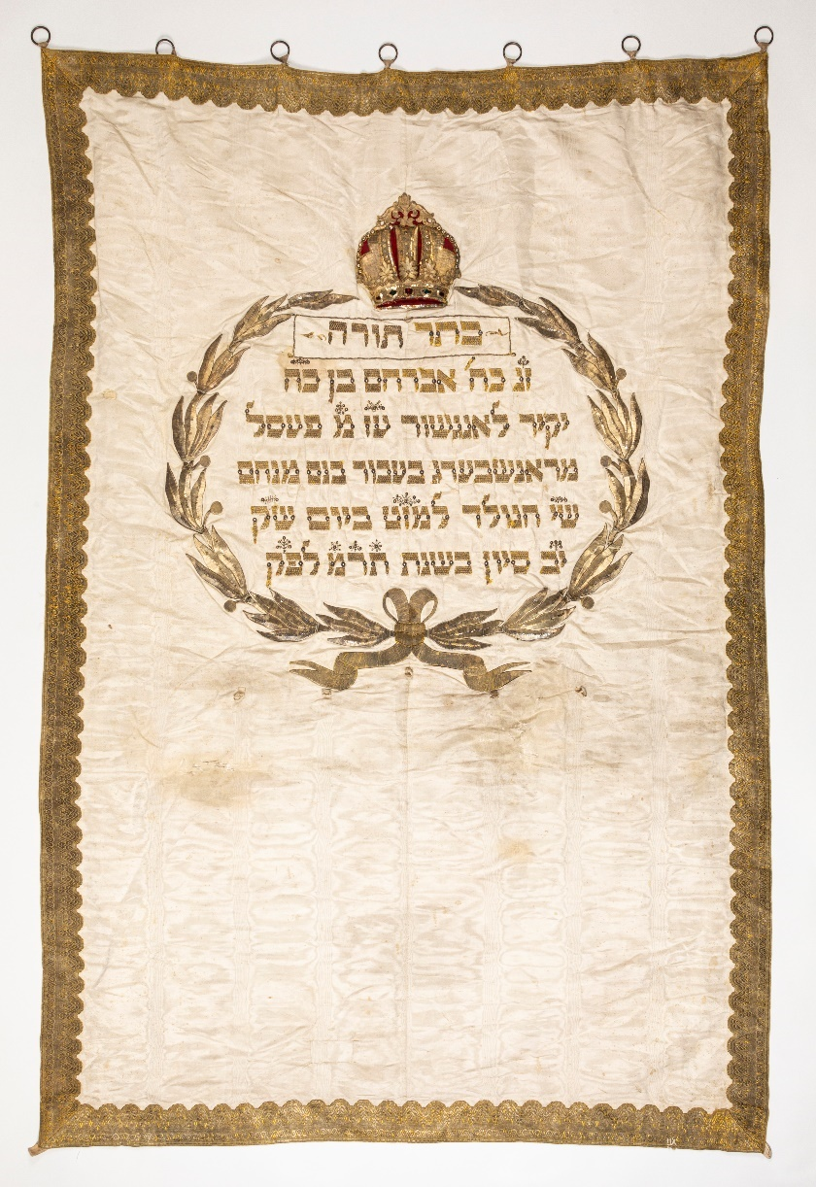
Torah ark curtain – Poběžovice (detail)

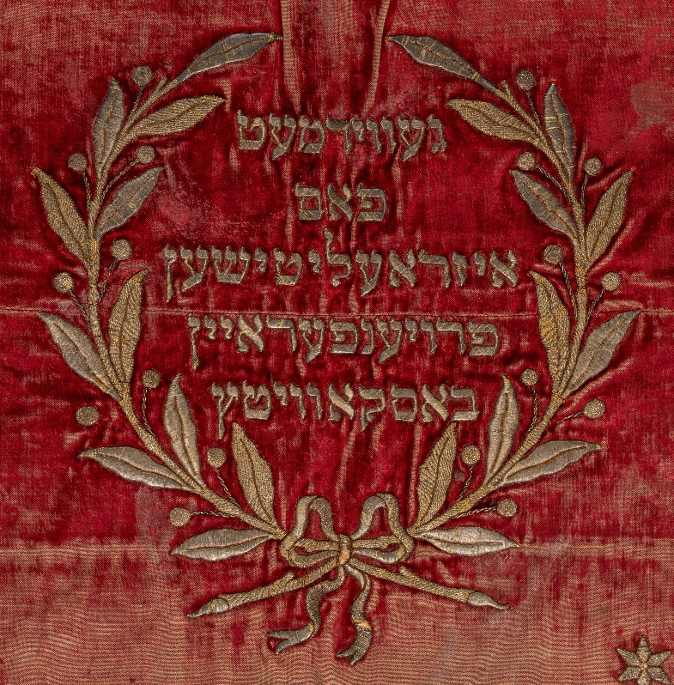
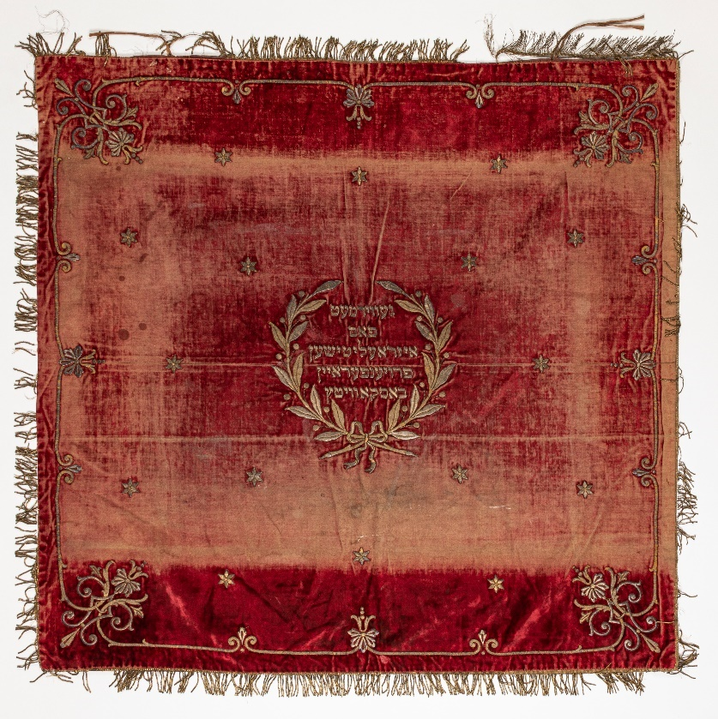
Torah reading table cover – Boskovice
Torah reading table cover – Boskovice (detail)
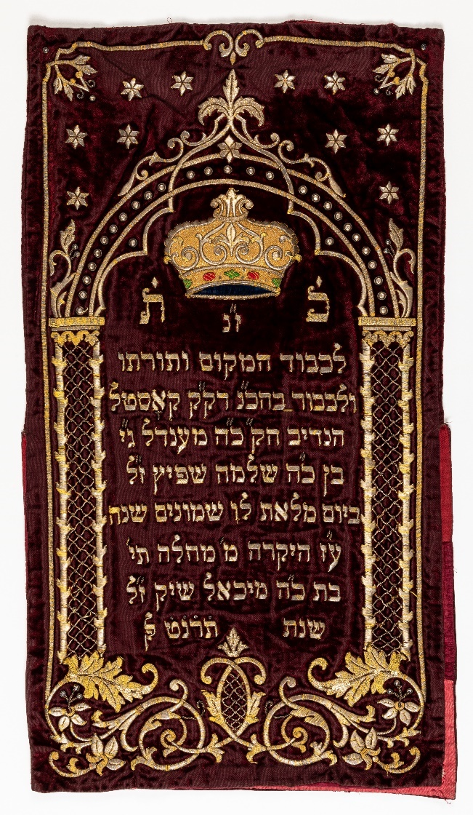
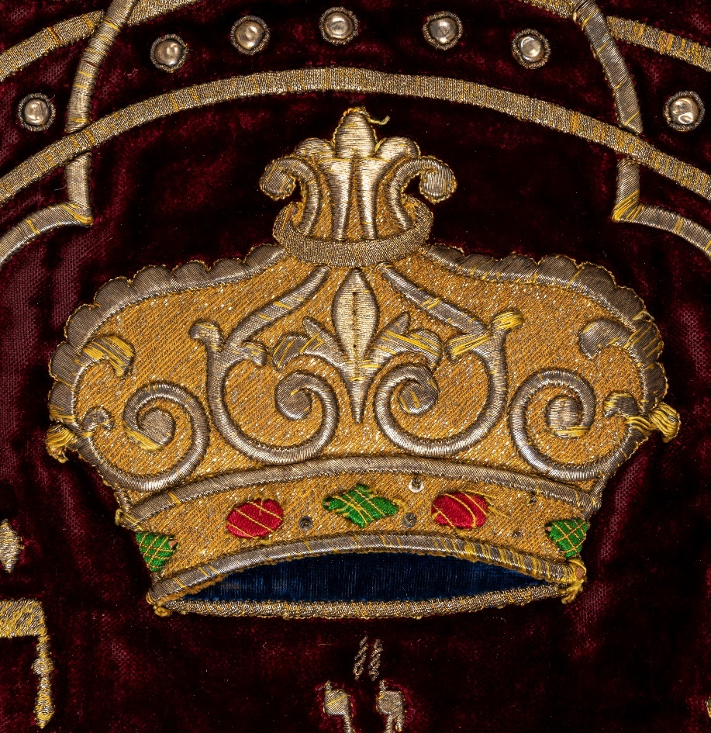
Torah mantle – Podivín (detail)
Torah mantle – Podivín

