AN EXHIBITION BY THE LEADING ISRAELI TYPOGRAPHER ODED EZER – ONE OF THE HIGHLIGHTS OF “KAFKA100”

PRAGUE, MAY 14, 2024

ODED EZER: THE SAMSA ENIGMA

On June 4 this year – which marks the centenary of the death of famed Prague writer Franz Kafka – the Robert Guttmann Gallery of the Jewish Museum in Prague will be launching an exhibition by the leading Israeli typographer and artist Oded Ezer. The installation, presented as mockumentary fiction, expands on the fantasy surrounding the protagonist of one of Kafka's most renowned stories. Gregor Samsa is portrayed as a forgotten literary prodigy whose writings have mysteriously vanished. Unlike Kafka, Samsa was not fortunate enough to have his manuscripts preserved, but Ezer takes his narrative even a step further by pointing out that the titles on the covers of twenty-four empty books are actually excerpts from the opening paragraph of The Metamorphosis, hinting at the possibility that Kafka himself might have appropriated Samsa's work.

The exhibition is curated by Michaela Sidenberg, the chief curator of the Jewish Museum in Prague, who describes the exhibition as follows: “It is a very compact installation that is centered around a narrative game in real space. Those who enter find themselves not only on the trail of a literary mystery, but also in the midst of Ezer’s drawings — images that represent fragments of the compulsive imaginings of an enigmatic author who is obsessed with writing. In this darkened space, reminiscent of an abandoned stage with highly expressive backdrops, it is possible to become immersed in one’s own reflections on the writing process, or to set about constructing one’s own story with no need to necessarily stick to Kafka’s original.”

Oded Ezer adds the following: “To me, Kafka serves as a metaphorical ‘third eye’ that impartially scrutinizes the world and sheds light on unsettling subjects that would otherwise remain unaddressed. His writing acts as a profound source of identification and awe, evoking a sense of admiration for his literary genius… Kafka has this amazing ability to make the reader identify with the hero of his stories. Although the story is completely imaginary – the protagonist, Gregor Samsa, wakes up one morning in his bed only to discover that he has turned, for no clear reason, into a giant vermin – it is told in such a realistic and ‘ordinary’ way, that makes the reader believe that it could happen to anyone, including himself.”
The actual technical design of the exhibition was a challenge. The gallery, including the floor, will be ‘wrapped’ in large-format prints, which must be able to withstand high loads. The prints were produced and installed for the exhibition by Perfect Print Services, s.r.o., which had to fine-tune the details with the author in order to achieve the intended effect of an atmosphere that will satisfy even the most demanding of viewers. The work was all the more challenging because everything was done remotely between Prague and Tel Aviv.
Martin Marek from Perfect Print Services, s.r.o. adds: “Viewers will be looking at the works from a very small distance, so we had to print at the highest possible resolution to meet the quality requirements. The Canon Colorado M5W with UVgel technology allowed us to find the optimal solution. The wall coverings are of a consistent color, highly flexible and abrasion resistant.”

Oded Ezer

Oded Ezer is a leading Israeli typographer, designer, educator, and creator of visual content around subjects such as science, medicine, anthropology, body art, ethics, literature, religion, history, sociology, politics, and writing systems. He collaborates with cultural and research institutions, non-profit organizations, and corporations. Among his clients are some of the world's most prestigious museums, galleries, and creative and research centers (MoMA, V&A Museum, Taiwan National Museum of Art, Design Museum Holon), major city festivals (Jerusalem Season of Culture, Palermo Capitale della Cultura, Jewish Culture Festival in Kraków), start-ups, and global companies (Google, Samsung, Waze). He also designed and illustrated the New American Haggadah (Little, Brown & Co., 2012). One of Ezer’s recent works is the design of a new logo and bilingual font for Israel’s legendary Weizmann Institute.
More information about Oded Ezer and his work is available on his official website at https://www.odedezer.com/.

Kafka100

This exhibition is part of “KAFKA100”, a year-long series of events organized by the Jewish Museum in Prague in commemoration of the centenary of this world-renowned writer from Prague. Among the other events in this series are the urban game “In Search of Odradek” and a series of public talks, seminars and discussions entitled “Transatlantic Kafka”. The Samsa Enigma exhibition will include guided tours with the curator Michaela Sidenberg, as well as an educational program for elementary and secondary school pupils. www.kafka100.cz

Contact for Media:

Michaela Klofcová, communications manager
michaela.klofcova@jewishmuseum.cz +420 734 775 041

Downloadable images for media use: https://drive.google.com/drive/folders/1ocunKYA0GYyHvxJ-Y2W295cMBvooYaHv?usp=sharing

This project is supported by the Ministry of Culture of the Czech Republic, Canon CZ, s.r.o., Perfect Print Services, s.r.o., and the Embassy of the State of Israel in the Czech Republic.

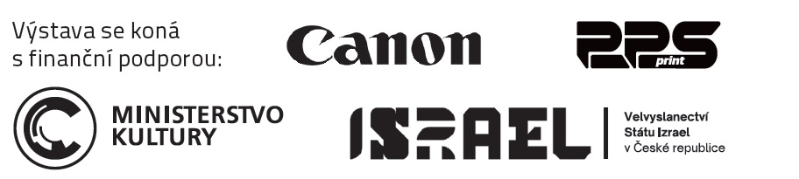

Perfect Print Services, s.r.o.

A design agency and printing company focusing on the production and sale of printed materials and POS materials for interior and exterior use. It also makes custom products in wood, metal and plastic, and also offers solutions for turnkey residential, office and commercial properties. www.pps-servis.com.

Canon CZ, s.r.o.

The Czech office of Canon Inc., a leading global supplier of digital imaging technologies and services. In addition to cameras, office devices and medical equipment, its portfolio includes equipment for large-format digital printing, including personalized wallpapers and decorative elements. www.canon.cz.



